**Configure Network and Setting up IP address**

**One or more of the following should be done.**

* 1. Setup Network Adapter if it’s Desktop connected to Switch / Network.
  2. Configure WIFI on your Laptop if WIFI Network is available
  3. Setup Microsoft KM-Test Loopback Adapter (**If (a) and (b) options are not available**)

**Setup Network Adapter if your desktop system is connected to Switch / Network:**

Right click on computer icon and then open the **open network and sharing center**

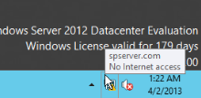

Click the Change adapter settings

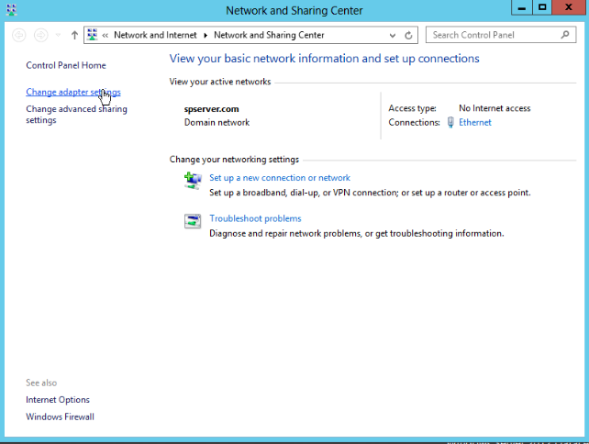

Double Click the Ethernet

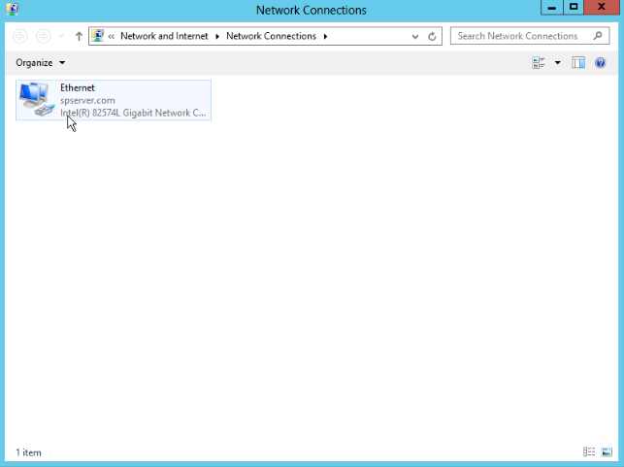

Click the properties

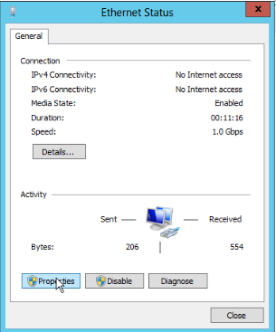

Double Click the Internet Protocol Version 4(TCP/IPv4)

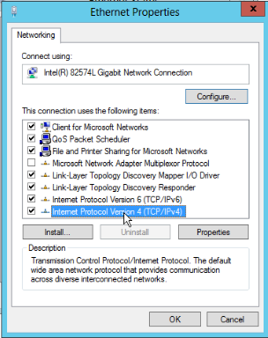

Set the IP address = 172.16.1.1

Subnet mask will be automatically set – Please don’t change that.

DNS = 127.0.0.1

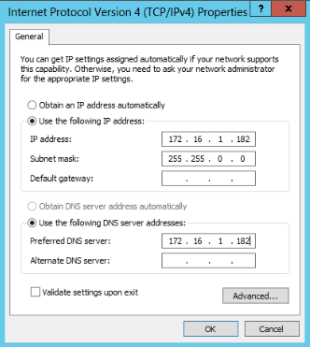

**Configuring Wireless LAN Service (WIFI) on Windows Server 2012**

Open the server manager and click **the add roles and features** option

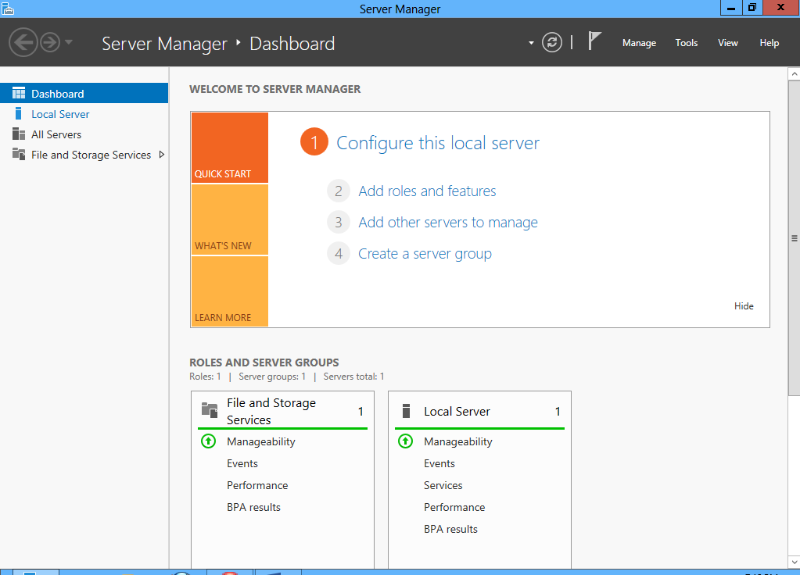

Click Next

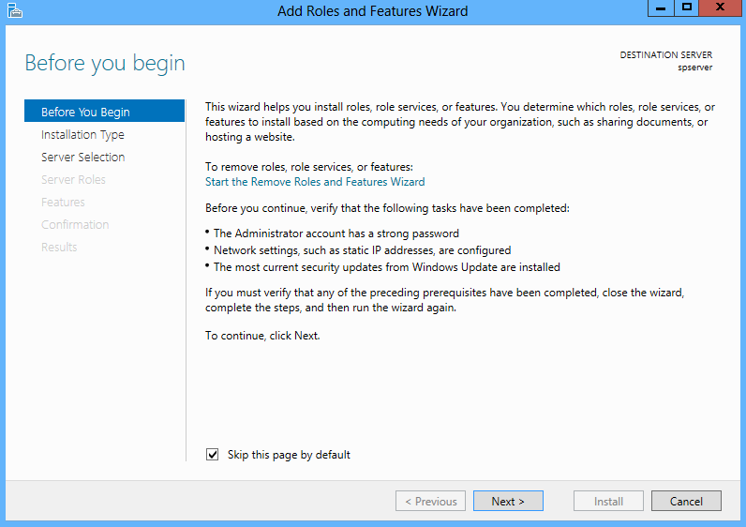

Click Next

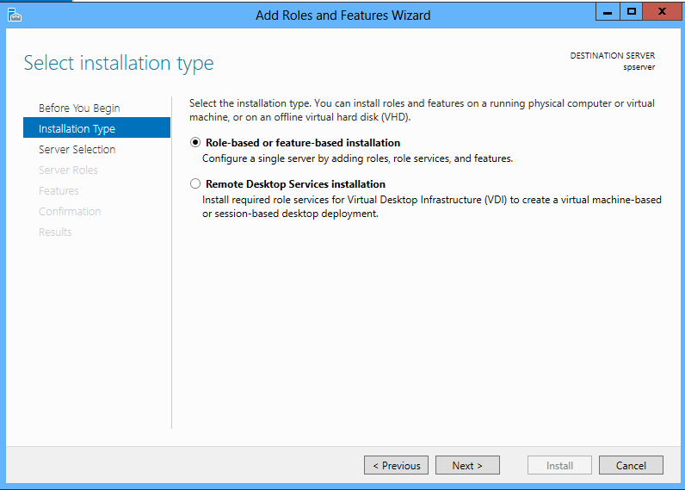

Name = Machine Name

IP = IP provided to the machine for WIFI network.

Click Next

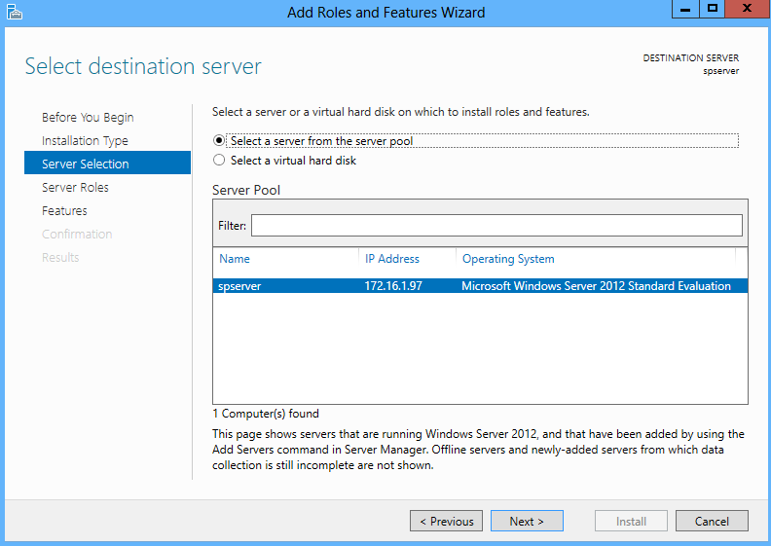

Click Next

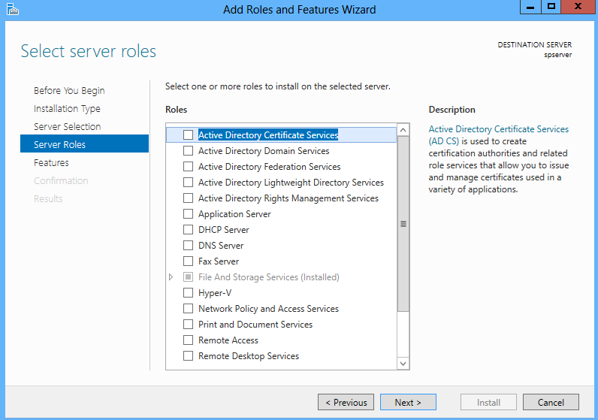

Select the Wireless LAN Service and click next

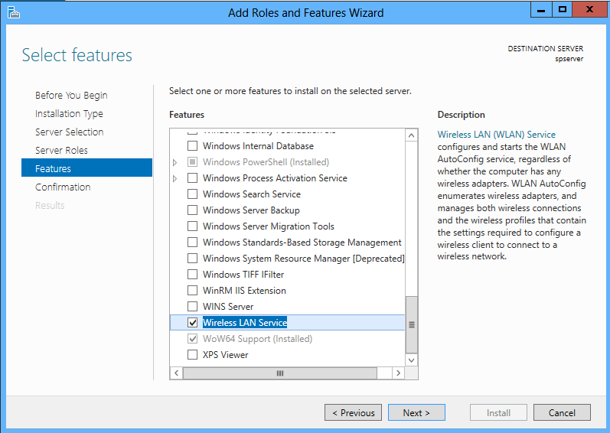

Click Install

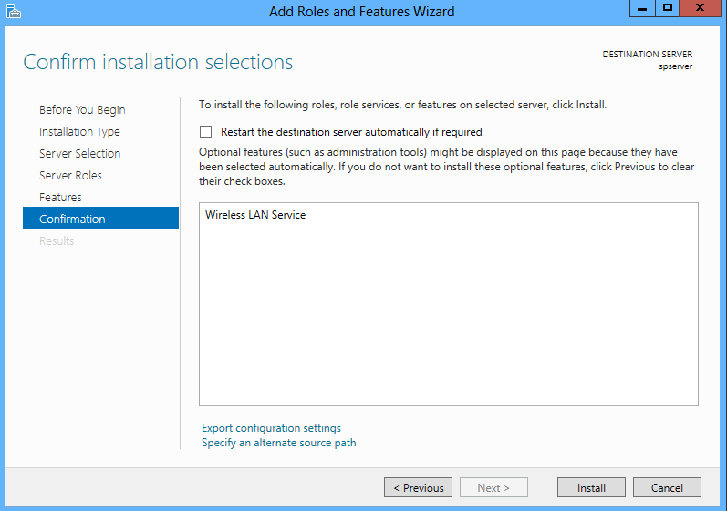

Click Close and Restart the system

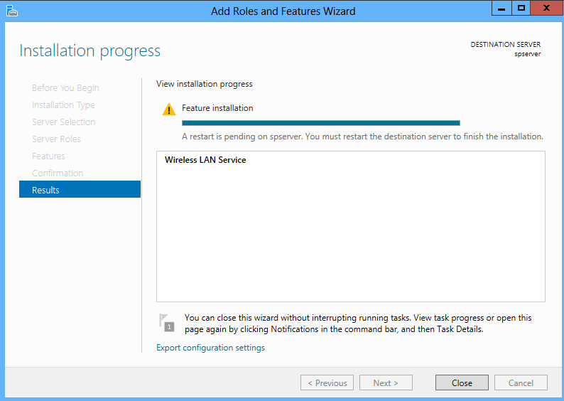

Now connect to the WIFI Network

**Setup Microsoft KM-Test Loopback Adapter**

Use this option if your system is not connected to network either using Network Adapter or WIFI.

1. Go to Control Panel 🡪 System
2. Click on Device Manager (This opens the New Window)
3. Go to Actions 🡪 Add legacy hardware

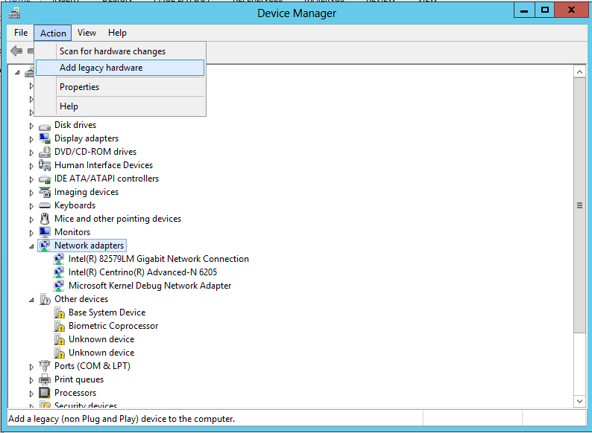

1. Next 🡪 Select Install the hardware that I manually Select from the list (advanced)

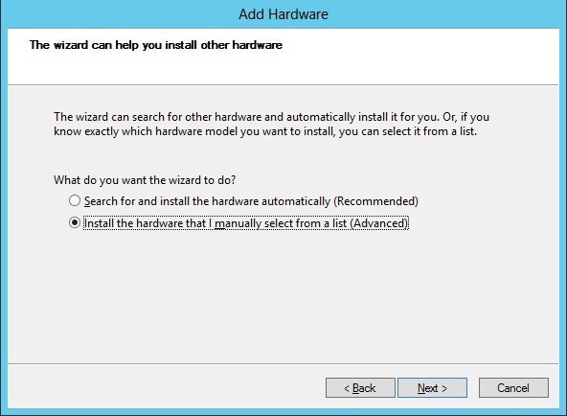

1. Select Network Adapters 🡪 Next

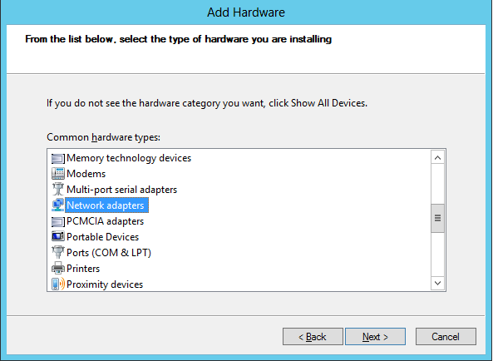

1. Select Manufacturer = “Microsoft”, Network Adapter=”Microsoft KM-Test Loopback Adapter”

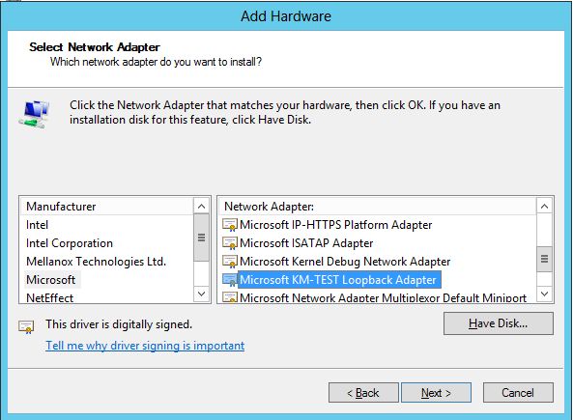

1. Next 🡪 Next 🡪 Finish.
2. Go to System Tray and Open Network and Sharing Center

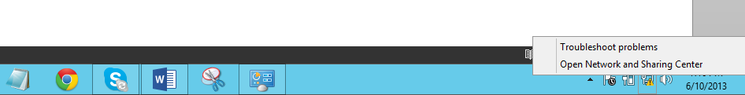

1. Click on Change Adapter Settings

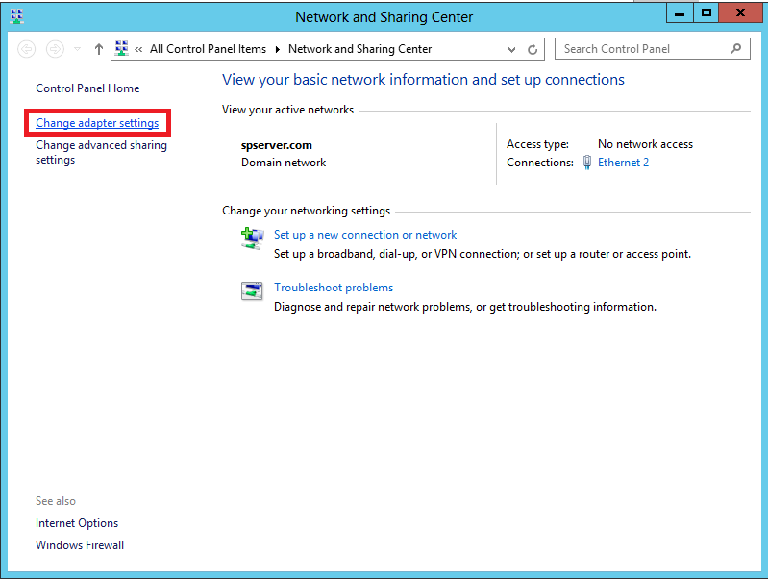

1. Right click on Microsoft KM adapter 🡪 Properties

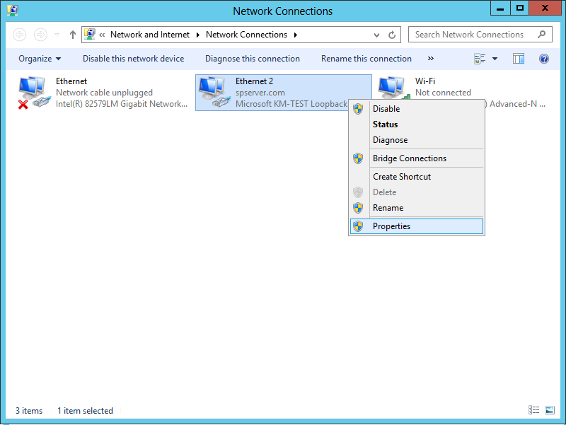

1. Select Internet Protocol Version 4 (TCP/IPv4) 🡪 Properties and provide the Settings as shown below:

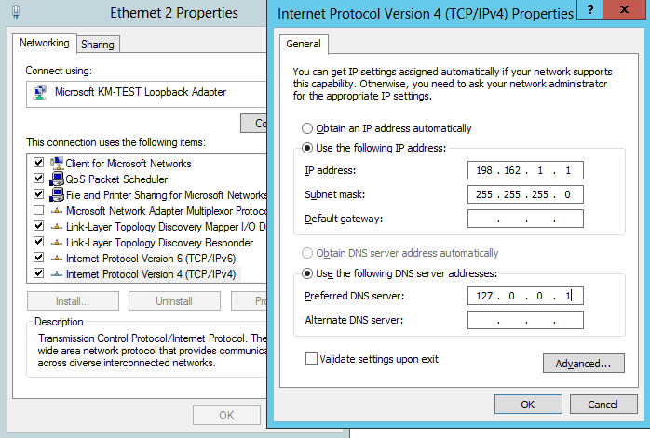

1. OK
2. Restart the system.